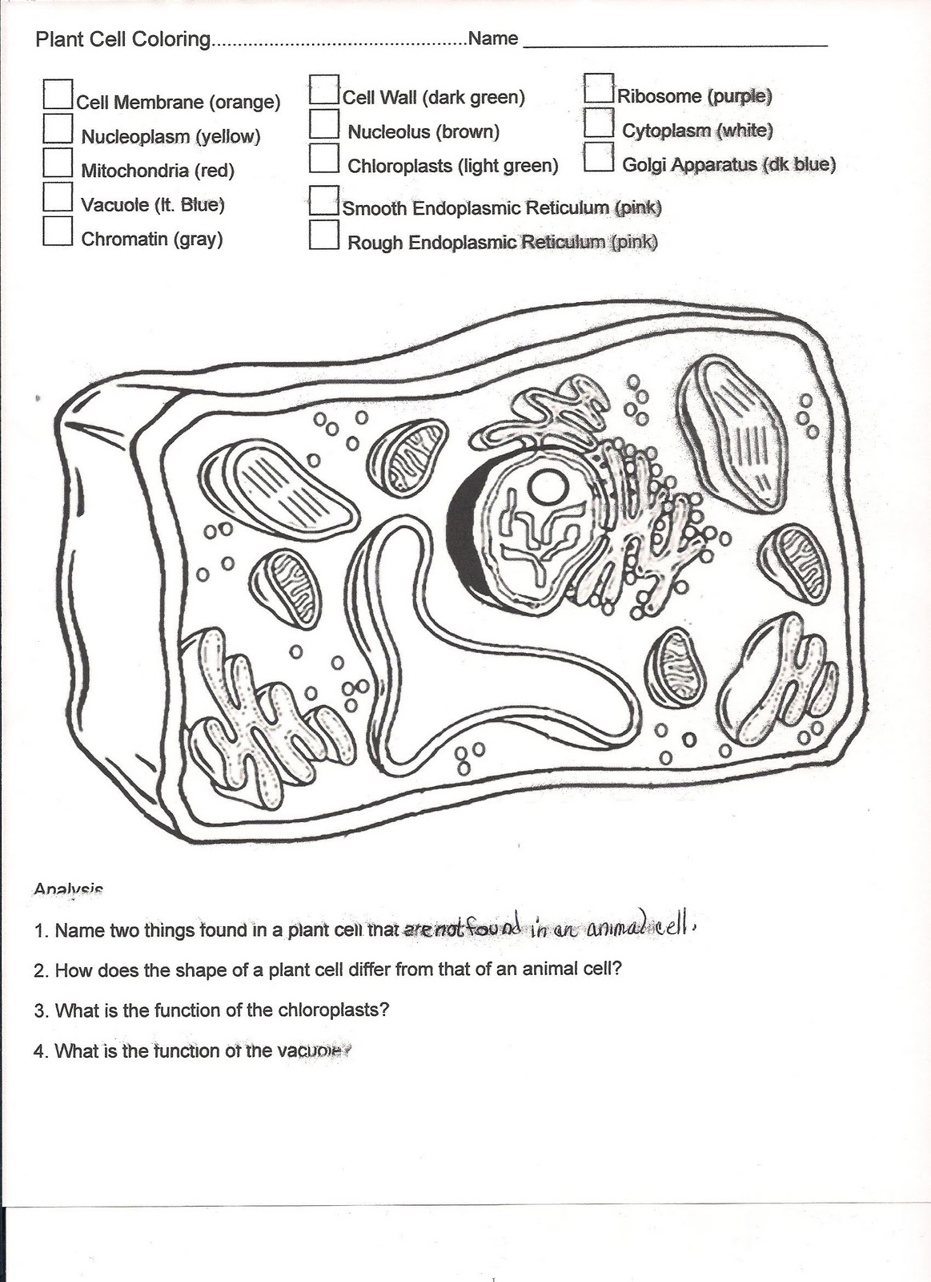

Complete these questions on page _______________________________

1. Name 2 things found in a plant cell that are not in an animal cell?
2. How does the shape of a plant cell differ from that of an animal cell?
3. Which is the function of the chloroplasts?
4. What is the function of the vacuole?