How Airplanes Work
by Marshall Brain, Robert Lamb and Brian Adkins

Introduction to How Airplanes Work
Human flight has become a tired fact of modern life. At any given moment, roughly 5,000 airplanes crisscross the skies above the United States alone, amounting to an estimated 64 million commercial and private takeoffs every year [source: NATCA]. Consider the rest of the world's flight activity, and the grand total is incalculable.
It is easy to take the physics of flight for granted, as well as the ways in which we exploit them to achieve flight. We often glimpse a plane in the sky with no greater understanding of the principles involved than a caveman.
How do these heavy machines take to the air? To answer that question, we have to enter the world of fluid mechanics.
Physicists classify both liquids and gases as fluids, based on how they flow. Even though air, waterand pancake syrup may seem like very different substances, they all conform to the same set of mathematical relationships. In fact, basic aerodynamic tests are sometimes performed underwater. To put it simply, a salmon essentially flies through the sea, and a pelican swims through the air.
The core of the matter is this: Even a clear sky isn't empty. Our atmosphere is a massive fluid layer, and the right application of physics makes it possible for humans to traverse it.
In this article, we'll walk through the basic principles of aviation and the various forces at work in any given flight.
aunch Video
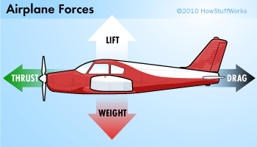
Airplanes take advantage of four forces.

How Do Planes Fly: Thrust and Drag
Drop a stone into the ocean and it will sink into the deep. Chuck a stone off the side of a mountain and it will plummet as well. Sure, steel ships can float and even very heavy airplanes can fly, but to achieve flight, you have to exploit the four basic aerodynamic forces: lift, weight, thrust and drag. You can think of them as four arms holding the plane in the air, each pushing from a different direction.
First, let's examine thrust and drag. Thrust, whether caused by a propeller or a jet engine, is the aerodynamic force that pushes or pulls the airplane forward through space. The opposing aerodynamic force is drag, or the friction that resists the motion of an object moving through a fluid (or immobile in a moving fluid, as occurs when you fly a kite).
If you stick your hand out of a car window while moving, you'll experience a very simple demonstration of drag at work. The amount of drag that your hand creates depends on a few factors, such as the size of your hand, the speed of the car and the density of the air. If you were to slow down, you would notice that the drag on your hand would decrease.
We see another example of drag reduction when we watch downhill skiers in the Olympics. Whenever they get the chance, they'll squeeze down into a tight crouch. By making themselves "smaller," they decrease the drag they create, which allows them to zip faster down the hill.
A passenger jet always retracts its landing gear after takeoff for a similar reason: to reduce drag. Just like the downhill skier, the pilot wants to make the aircraft as small as possible. The amount of drag produced by the landing gear of a jet is so great that, at cruising speeds, the gear would be ripped right off the plane.
For flight to take place, thrust must be equal to or greater than the drag. If, for any reason, the amount of drag becomes larger than the amount of thrust, the plane will slow down. If the thrust is increased so that it's greater than the drag, the plane will speed up.

How Do Airplanes Fly: Weight and Lift
Every object on Earth has weight, a product of both gravity and mass. A Boeing 747-8 passenger airliner, for instance, has a maximum takeoff weight of 487.5 tons (442 metric tons), the force with which the weighty plane is drawn toward the Earth.
Weight's opposing force is lift, which holds an airplane in the air. This feat is accomplished through the use of a wing, also known as an airfoil. Like drag, lift can exist only in the presence of a moving fluid. It doesn't matter if the object is stationary and the fluid is moving (as with a kite on a windy day), or if the fluid is still and the object is moving through it (as with a soaring jet on a windless day). What really matters is the relative difference in speeds between the object and the fluid.
As for the actual mechanics of lift, the force occurs when a moving fluid is deflected by a solid object. The wing splits the airflow in two directions: up and over the wing and down along the underside of the wing.
The wing is shaped and tilted so that the air moving over it travels faster than the air moving underneath. When moving air flows over an object and encounters an obstacle (such as a bump or a sudden increase in wing angle), its path narrows and the flow speeds up as all the molecules rush though. Once past the obstacle, the path widens and the flow slows down again. If you've ever pinched a water hose, you've observed this very principle in action. By pinching the hose, you narrow the path of the fluid flow, which speeds up the molecules. Remove the pressure and the water flow returns to its previous state.
As air speeds up, its pressure drops. So the faster-moving air moving over the wing exerts less pressure on it than the slower air moving underneath the wing. The result is an upward push of lift. In the field of fluid dynamics, this is known as Bernoulli's principle.
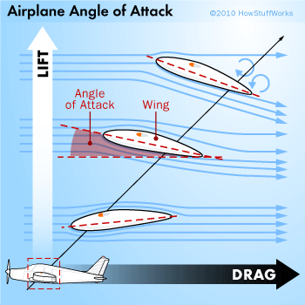

Aerial Navigation: Wings, Slats and Flaps
Having covered the basic physics of flight and the ways in which an airplane uses them to fly, the next obvious step is to consider navigation. How does an airplane turn in the air? How does it rise to a higher altitude or dive back toward the ground?
First, let's consider the angle of attack, the angle that a wing (or airfoil) presents to oncoming air. The greater the angle of attack, the greater the lift. The smaller the angle, the less lift. Interestingly enough, it's actually easier for an airplane to climb than it is to travel at a fixed altitude. A typical wing has to present a negative angle of attack (slanted forward) in order to achieve zero lift. This wing positioning also generates more drag, which requires greater thrust.
In general, the wings on most planes are designed to provide an appropriate amount of lift (along with minimal drag) while the plane is operating in its cruising mode. However, when these airplanes are taking off or landing, their speeds can be reduced to less than 200 miles per hour (322 kilometers per hour). This dramatic change in the wing's working conditions means that a different airfoil shape would probably better serve the aircraft. Airfoil shapes vary depending on the aircraft, but pilots further alter the shape of the airfoil in real time via flaps and slats.
During takeoff and landing, the flaps (on the back of the wing) extend downward from the trailing edge of the wings. This effectively alters the shape of the wing, allowing it to divert more air, and thus create more lift. The alteration also increases drag, which helps a landing airplane slow down (but necessitates more thrust during takeoff).
Slats perform the same function as flaps (that is, they temporarily alter the shape of the wing to increase lift), but they're attached to the front of the wing instead of the rear. Pilots also deploy them on takeoff and landing.
Pilots have to do more than guide a plane through takeoff and landing though. They have to steer it through the skies, and airfoils and their flaps can help with that, too.

THE LIFT COEFFICIENT
In determining the lift of a given airfoil, engineers refer to its lift coefficient. This number depends on air speed, air density, wing area and angle of attack.

Aerial Navigation: Stabilizers, Ailerons, Rudders and Elevators
The tail of the airplane has two types of small wings, called the horizontal and vertical stabilizers. A pilot uses these surfaces to control the direction of the plane. Both types of stabilizer are symmetrical airfoils, and both have large flaps to alter airflow.
On the horizontal tail wing, these flaps are called elevators as they enable the plane to go up and down through the air. The flaps change the horizontal stabilizer's angle of attack, and the resulting lift either raises the rear of the aircraft (pointing the nose down) or lowers it (pointing the nose skyward).
Meanwhile, the vertical tail wing features a flap known as a rudder. Just like its nautical counterpart on a boat, this key part enables the plane to turn left or right and works along the same principle.
Finally, we come to the ailerons, horizontal flaps located near the end of an airplane's wings. These flaps allow one wing to generate more lift than the other, resulting in a rolling motion that allows the plane to bank left or right. Ailerons usually work in opposition. As the right aileron deflects upward, the left deflects downward, and vice versa. Some larger aircraft, such as airliners, also achieve this maneuver via deployable plates called spoilers that raise up from the top center of the wing.
By manipulating these varied wing flaps, a pilot maneuvers the aircraft through the sky. They represent the basics behind everything from a new pilot's first flight to high-speed dogfights and supersonic, hemisphere-spanning jaunts.
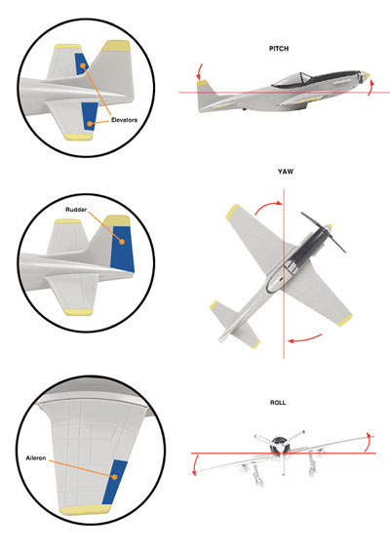

Aircraft Motions and the Principle Axes
As we explored on the last two pages, flaps and slats enable a pilot to move an aircraft through three-dimensional space. In other words, the pilot alters the plane's orientation around its own center of gravity, producing torque. Imagine this center of gravity as a fixed point in the middle of the fuselage. Next, imagine an invisible horizontal line that travels straight through the plane's nose, center of gravity and tail. We call this the roll axis.
By adjusting the plane's ailerons (or spoiler) a pilot can cause the lift to increase in one wing and decrease in the other. One wing rises, the other descends. This causes the body of the plane to rotate along its roll axis, which results in a maneuver known as a roll. When a plane makes a complete rotation of its roll axis, the maneuver is called a barrel roll. However, when a pilot merely rolls enough to tilt the angle of the airfoil, the aircraft banks or turns.
Now imagine an invisible vertical line intersecting the center of gravity, shooting down through the top of the aircraft and out through the belly. This is called the yaw axis, and it comes into play when a pilot manipulates the aircraft's rudder. The rudder's deflection results in a side force, rotating the tail in one direction and the nose in the other. This is called a yaw motion, which helps the pilot to maintain course.
Finally, imagine an invisible horizontal line moving through the sides of the aircraft's center of gravity, roughly parallel to the wings. This is the pitch axis, which necessitates the pitch motion due to changes in the airplane's elevator. When the tail tilts down, the nose rises and the plane ascends -- and vice versa. Some aircraft can actually perform complete loops in this manner.
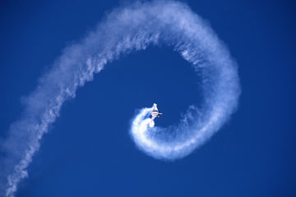
Spiral of smoke from Eurofighter Typhoon jet
Andrew Holt /Photographer's Choice/Getty Images

Stalls and Spins
As we covered earlier, an aircraft's flight is a careful balance of thrust, drag, weight and lift. Should lift decrease and drag increase suddenly, such as when an aircraft's angle of attack surpasses that for maximum lift, a stall occurs. The airframe shakes and the plane falls, at least for a few feet. In most cases the pilot merely corrects for the stall by lowering the plane's angle of attack. However, an improperly corrected stall can result in a secondary stall, or degrade into a spin.
If you've ever attended an air show, you've probably witnessed stunt pilots intentionally entering into spins as part of an aerial acrobatics show. Typically, you'll see the prop-driven plane soar upward in a steep ascension, only to stall out and fall into a dramatic spin. The principles of an accidental spin are much the same.
A spin has three basic phases. The initial phase is called an incipient spin, in which the droppingaircraft starts to enter the spin. This phase lasts only a few seconds in light aircraft.
If uncorrected, an incipient spin degrades into a fully developed spin composed of a near-vertical helical flight path -- as if the plane is descending an invisible spiral stair. Such a spin can cost an aircraft hundreds of feet with every turn.
In a flat spin, the pitch and roll axes remain steady, with the spin occurring around the plane's center of gravity. In other words, the plane is mostly level as it falls in an extremely dangerous spin.
Spin recovery techniques vary depending on the design of a given aircraft and where its center of gravity is situated. Generally speaking, a plane with its center of gravity more toward the nose is less likely to enter a spin than one with the center of gravity located closer to its tail. As such, some aircraft have specific spin recovery procedures, but the idea is to disrupt spin equilibrium and force the craft to stall and from there correct back into controlled flight.
Most pilots aren't looking to take their passengers for a spin though. They're too busy manning the flight instruments we'll talk about next.
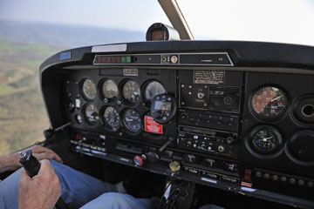
Flight instruments help pilots keep an eye on conditions.

Flight Instruments
To the untrained eye, a panel of flight instruments may seem like a smorgasbord of dials. But all these crucial gauges provide a pilot with critical data during the flight. The six most basic flight instruments, as found in a simple prop-driven plane, are as follows:
- Airspeed indicator: Essentially, this gauge tells the pilot how fast the aircraft is traveling in relation to the ground. The indicator depends on a differential pressure gauge, not unlike a tire gauge.
- Altimeter: As the name implies an altimeter measures altitude. The indicator in this case is abarometer, which measures air pressure.
- Attitude indicator: Remember the three primary principle axes we mentioned before (pitch, yaw and roll)? Well, an attitude indicator illustrates the aircraft's orientation along all three. By use of a gyroscope, the indicator provides spatial clarity even in disorienting flight conditions.
- Heading indicator: The heading indicator simply tells the pilot in which direction the plane is heading. The device depends on both a gyroscope and a magnetic compass, however, as both are susceptible to different errors during flight.
- Turn coordinator: A typical turn coordinator indicates the plane's yaw or roll rate while also indicating the rate of coordination between the plane's bank angle and the rate of yaw. This device depends on a gyroscope, as well as an inclinometer ball in a glass cylinder to indicate when the aircraft is skidding or slipping.
- Variometer: Also known as a vertical speed indicator, this device indicates the rate of a plane's rate of climb or descent. Working along similar lines as the altimeter, the variometer depends on atmospheric pressure readings to determine how swiftly altitude changes are occurring.
The total number of flight instruments has increased over the years with the speed, altitude, range and overall sophistication of the aircraft.
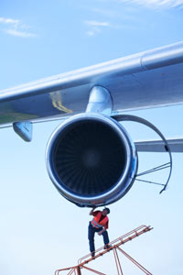
A flight mechanic attends to a modern gas turbine engine.
James Lauritz/ Photographer's Choice RF/Getty Images

Fueling Flight: Means of Propulsion
When it comes to propelling an airplane through the sky, different designs depend on different means of propulsion to provide thrust. Most methods, however, work along the same basic principle: An engine accelerates a gas.
Let's peek inside a few different engines.
Propeller engine: In a typical propulsion system, an engine mixes fuel with air and burns the fuel to release the energy. The resulting heated gas moves a piston, which is attached to a crankshaft. This spins a propeller, or prop, which is essentially an array of spinning wings. Each blade is an airfoil with an angle of attack. The angle is greater toward the center because the speed of the propeller through the air is slower close to the hub. Many larger prop-driven aircraft boast propellers with adjustable pitch mechanisms. These mechanisms let the pilot adjust the propeller's angle of attack depending on air speed and altitude. There are, of course, variations. For example, in turbo prop planes, a gas turbine spins the propeller, and electric aircraft designs don't employ combustion.
Rocket engine: While a propeller engine uses the surrounding air as the working fluid of its propulsion, all a rocket needs is the thrust of its own combustion exhaust gas. This is why a rocket can provide thrust in space, but a propeller cannot. A rocket engine combines fuel and an internal source of oxygen called an oxidizer. The oxygen and fuel ignite in a combustion chamber, exploding in a hot exhaust. These gases pass through a nozzle to produce thrust.
Gas turbine engine: Also known as a jet engine, this means of propulsion works a lot like a rocket engine, only it obtains the necessary air from the surrounding atmosphere rather than a tank. As such, jet engines don't work in space either. Many variants of gas turbine engines, such as those seen on most airliners, collect the necessary air through fanlike rotary compressors. A ramjet, however, doesn't use a compressor. Instead, the airplane builds up speed, which forces air through forward-facing vents in the engine. In this model, the aircraft's speed naturally compresses the air necessary for combustion.
Now that we've covered engines, let's get some serious speed.
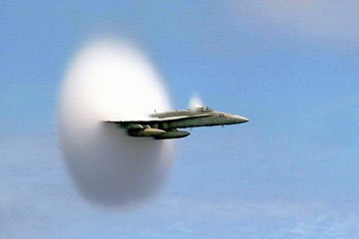
An F/A-18 Hornet emerges from a cloud created when it broke the sound barrier.
John Gay/US Navy/Getty Images

Aircraft Speed
Once fueled, an airplane's minimum flight speed depends on the movement of the air around it. Maximum airspeed, on the other hand, is limited largely by technology. We use the speed of sound as the ultimate measuring stick for airplane velocity, and this is quite simply the rate at which a sound wave moves through a gas.
The exact speed of sound depends on the elasticity and density of the gas medium it's traveling through -- which means varying air pressure and air temperature prevent the existence of a global speed of sound. At 32 degrees Fahrenheit (0 degrees Celsius), the speed of sound in air is 1,087 feet per second (331 meters per second). Raise the temperature to 68 degrees Fahrenheit (20 degrees Celsius), and the speed climbs to 1,127 feet per second (343 meters per second).
Whatever the details of the medium, we refer to the speed of sound as Mach 1, named after physicist Ernst Mach. If an airplane reaches the speed of sound, its speed is Mach 1. If the airplane reaches double the speed of sound, its speed is Mach 2.
Airplanes speeds that are less than Mach 1 are considered subsonic speeds, while those very close to Mach 1 are said to be transonic. Velocities surpassing the speed of sound are divided into high supersonic (Mach 3 through Mach 5) and hypersonic(Mach 5 through Mach 10). Speeds swifter than Mach 10 are considered high hypersonic.
If you've ever heard a supersonic aircraft fly overhead, then you've probably heard a sonic boom. Once an airplane attains Mach 1, the sound waves emitted by the plane can't speed ahead of it. Instead, these waves accumulate in a cone of sound behind the plane. When this cone passes overhead, you hear all that accumulated sound at once.
We'll head inside the airplane next to investigate which cabin systems work to keep us healthy at high altitudes.
You know the drill.
© iStockphoto.com/ gchutka

Under (Cabin) Pressure
Sure, humans evolved to thrive in Earth's atmosphere, but it's important to realize that we only evolved to thrive in a thin layer of the planet's gaseous outer layer. Air pressure changes depending on altitude. In the same way that the water pressure in the ocean is greater on the seafloor than it is just below the surface, air pressure decreases the higher you ascend through the atmosphere.
When humans breathe thinner, high-altitude air, they have a harder time taking in enough oxygen. And when we hang out at heights higher than 9,800 feet (3,000 meters), our bodies become susceptible to a host of unpleasant or even deadly illnesses, like these:
Altitude sickness: Also the bane of high-altitude mountain climbers, reduced air pressure and lower oxygen concentration levels can cause extreme shortness of breath due to fluid buildup in the lungs. In extreme cases, this can lead to brain swelling, resulting in confusion, coma or death.
Ear barotrauma: The Eustachian tube connects your middle ear to the outside world. If this tube becomes blocked, changes in atmospheric pressure can cause a pressure differential that can result in dizziness, discomfort, hearing loss, ear pain and nose bleeds.
Decompression sickness: Divers know this condition as the bends, and it can occur in the air, as well as in the water. Exposure to low barometric pressures can cause dissolved nitrogen in the blood stream to form harmful bubbles that can cause everything from drowsiness to stroke.
Hypoxia: As low pressure means less oxygen in every breath you breathe, the brain receives less oxygen at high altitudes. The physiological results often include cognitive impairment or light-headedness, which can seriously impair a pilot's ability to fly the plane.
Pressurized cabins enable pilots, crew and passengers to avoid these pitfalls of flying at high altitude. While the air outside the cabin thins out the higher a plane climbs, compressed air inside the cabin maintains more surface-level air pressure and oxygen-rich air. In the event of accidental loss of cabin pressure, emergency oxygen masks provide the necessary air quality.
Pressurized flight suits achieve the same effect as pressurized cabins, only on an individual basis. Characterized by enclosed helmets, these suits typically see use in military and high-performance aircraft.

Landing Gear
We've discussed the parts of an airplane necessary for flight, but just as a bird eventually needs to stretch its legs, so too does an airplane require some form of landing gear. The gear in turn requires an undercarriage, or a structure that supports the plane's weight on the ground.
The Wright brothers' 1903 flyer depended on simple wooden skids for landing in the sand. Other more modern craft to possess landing skids include the German Messerschmitt ME 163 Komet, aWorld War II rocket-propelled interceptor, and the U.S. Air Force's X-15, an experimental, high-speed 1960s jet. Along similar lines, some aircraft boast floats or skis for landing on water, snow or ice.
When you think of landing gear, however, you probably think of the wheeled variety. The actual wheels involved have ranged over the vast spectrum of aviation designs. Some early landing gear resembled bicycle wheels while larger aircraft often feature bogie landing gear that employ sets of four or more wheels on each brace. During the 1950s, the U.S. Air Force even experimented with tank-style tracked landing gear for the enormous six-engine Convair B-36 Peacemaker.
Regardless of the type of wheel employed, such landing gear are typically arranged in one of two arrangements. First there's the conventional undercarriage with two front wheels and one smaller tail wheel or skid. You can spot this arrangement, also known as a taildragger undercarriage, on older prop-driven aircraft. Most modern planes use a tricycle undercarriage, in which the smaller wheel is positioned at the front of an aircraft.
Variations on these two basic themes are numerous, with additional wheels added depending on the particular demands of a given aircraft. The Lockheed U-2, for instance, features a tandem design with two fuselage wheels running down the middle and supporting wheels on each wing for balance. Many modern aircraft featureretractable landing gear, which pull up into fuselage during flight, but others still feature fixed landing gear that remain extended all the time.
But what if your plane is prevented from making a conventional landing? That's next.
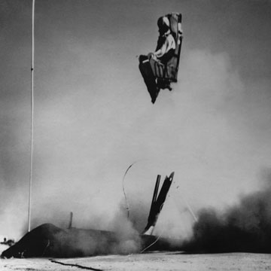
A 1958 U.S. Navy ejection seat hurls a dummy into the air.
Keystone/Stringer/Hulton Archive/Getty Images

Ejection Seats, Escape Pods and Evacuation Slides
Modern aircraft enable passengers to wine, dine and even catch a good night's sleep without any worries over the plane's soaring altitude or the mechanical means that keep them there. When something goes wrong, however, you need to be able to exit the plane and live to tell the story on the ground.
As such, planes have boasted several ingenious escape features over the years. Let's walk through some of the ways you might try to exit an aircraft in an emergency.
The evacuation slide: No one wants to abandon an airplane before landing, so if it's possible, pilots attempt to regain control or at least achieve a crash landing. At this point, you generally want to flee as far from the damaged airplane as possible. This is where the evacuation slide comes in handy. Compressed gas inflates the slide, allowing for speedy deployment. A passenger then slides down and, in some cases, the inflatable slide can be used as a flotation device.
The parachute: The first parachute jump from an airplane took place in 1912, a mere nine years after the Wright brothers' inaugural flight. It has remained an aviation staple, creating drag to slow down a moving object, person or aircraft. You won't find a cache of emergency chutes on a commercial airliner, however, as they typically operate at speeds and altitudes that would require additional safety gear. Skydiving also calls for individual training and regular parachute maintenance -- to say nothing of the logistics involved in evacuating a plane full of passengers in such a manner.
The ejection seat: This option generally remains the exclusive domain of military and experimental aircraft. While it was possible for the pilots of older, prop-driven aircraft to climb out of a plummeting aircraft, the pilots of high-performance jets require a fast, automated exit from a doomed aircraft. Ejection seats achieve this by simply blasting the pilot's or passenger's seat free of the plane. Then a parachute deploys to provide the necessary drag to slow the descent back to the surface.
The escape capsule: In extreme conditions, military or experimental aircraft feature escape capsules for pilots or crew members. The principle is the same as that of an ejection seat, only instead of jettisoning a pilot in a naked seat, it entails the ejection of a pressurized pod. Some aircraft designs even go so far as to eject entire crew cabins as a single, multiperson escape capsule.

PLANES INSIDE PLANES
If you absolutely have to leave an airplane midflight, wouldn't it be nice to leave in another airplane? Despite what you may have seen in movies, this generally is not an option. Numerous prototypes have explored the use of parasite vehicles (small aircraft that deploy from a larger plane midflight), but they generally involved the use of fighter aircraft. Plus, even if an aircraft had room to carry escape planes for its entire crew, a plummeting airplane would hardly allow for a leisurely departure.
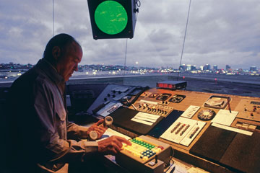
An air traffic controller monitors the skies.
Comstock/Comstock Images/Getty Images

Communication in the Skies
At the very beginning of this article, we discussed the thousands upon thousands of aircraft that fill the sky regularly. How do they avoid crashing into each other and landing without unleashing absolute chaos? Well, we have the field of avionics to thank.
Avionics entails all of an aircraft's electronic flight control systems: communications gear, navigation system, collision avoidance and meteorological systems. An overarching aerospace and air traffic control system ensures the safety of commercial and private aircraft as they take off, land and traverse vast distances without incident. Through the use of radar, computerized flight plans and steady communication, air traffic controllers ensure planes operate at safe distances from each other and redirect them around bad weather.
Needless to say, global air traffic control is a colossal task. It essentially involves governance of the skies, so we tackle that operation similarly to how we would on the ground: We divide things up. U.S. airspace, for example, breaks down into 21 air route traffic control centers (ARTCCs), each a designated territory that spans whole states and more. Internationally, you'll also hear these airspaces called area control centers (ACCs). Depending on a country's size, they may employ one or several ACCs.
If a flight takes a plane across several countries, it passes through various ACCs, each monitored by different air traffic controllers who give instructions to the pilot as needed. If a flight takes a plane into international airspace (the air above international waters), the crew will still depend on the assistance of an ACC, though the ground controllers may have to forgo the use of radar and depend on pilot reports and computer models. For a more in-depth look, read How Air Traffic Control Works.
Explore the links on the next page to learn even more about aviation.

